**Assignment 1**

**Student Name: Jiaming Han**

**ID: B00726481**

**A1.1**

**I choose “Halifax Waterfront”.**

This website describes a beautiful part of the city Halifax, just like the name “Halifax Waterfront”. Before we are getting start to look through this website, we should know about the website’s users, who are they and what are they looking for. When people search the keyword “Halifax Waterfront”with search engine, they are probably going to know the history, or doing some research for the development of this area, or just come to travel and join in some interesting events. So basically, no matter they are businessman, scholars or travelers, they all have a common purpose, to get more personal experience for this beautiful place.

Here is going use 3 different cases to show what are website users looking for. Just imagine that, if people planning to travel to the Halifax Waterfront, the first step that they are going to do is get in the website then find the location and travel route. Also, concern about the dining, living, and parking. they would search and choose hotels, restaurants and parking lots on the list. people could also check the date of any events that they want to join in. That is all for travelers looking for in this website. What about scholars, they must do researches and finish their academic papers, so what these students care about are mostly history and development of this place. If some students want doing research for Halifax waterfront, then they could click the “history” module of this website, then look through the historical records over the past three decades to know what happened before, and this website would be one their reference. Also, students can click the “development” parts of this website to contrast the differences of the place between past three decades and today. It also would be one part of their reference. For the businessman, they will consider more about the news, social media and economic development, because these are part of the market trend. So, they can click “News and media “module of this website, they will find many latest news of Halifax Waterfront. Moreover, businessman can follow the Facebook, Twitter or YouTube to see the public opinion for this place, and, they could popularize their companies and products with these social applications. if some businessman wants to have more specific information like government policies or employment, then they could just click “About” module of this website, they would find some information they want to know.

That is all characteristics of the website`s users. Generally, they are any of people who want to know about Halifax waterfront, and these users of different occupations also want to understand this place from a different perspective, that is also this website has.

**A1.2**

**To Evaluate the Website**

Now, we are going to use “Nielsen’s usability heuristic” to perform an evaluation of this

Website that named “Halifax Waterfront”.

1. The first principles are “Visibility of system status”. When the system executes some specific operation, it should let the user know what status it is. For instance, if I download a pdf document from the website “Halifax Waterfront”, then I could see what status this website is. Also, as we can see, in the bottom of the homepage, there are some contact numbers, such as phone number, fax number, email address, etc., and these contact numbers are easy to find out, so users can call or send feedback at any office hours. So, this website passes the first principles successfully.

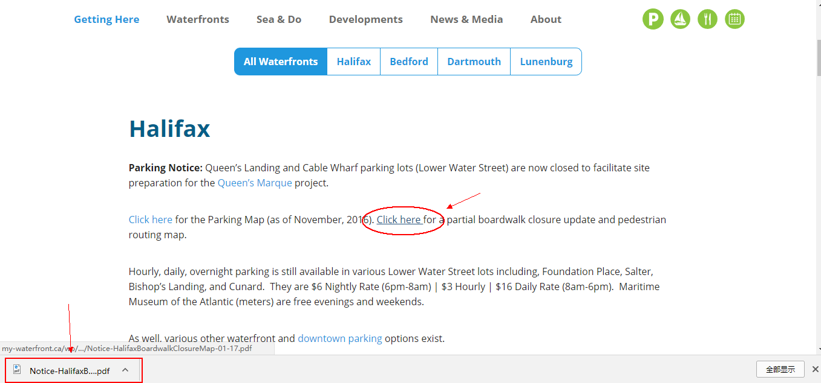





1. The second principles are “Match between system and the real world”, which means the system should speak common language, no system-oriented terms, no professional words. After looking through this website, we didn`t find any complex system-oriented terms and even long sentences. There are all simple words for any users to understand, and users can easily find out the answer that they want to know. Generally, this website passes the second principles successfully.

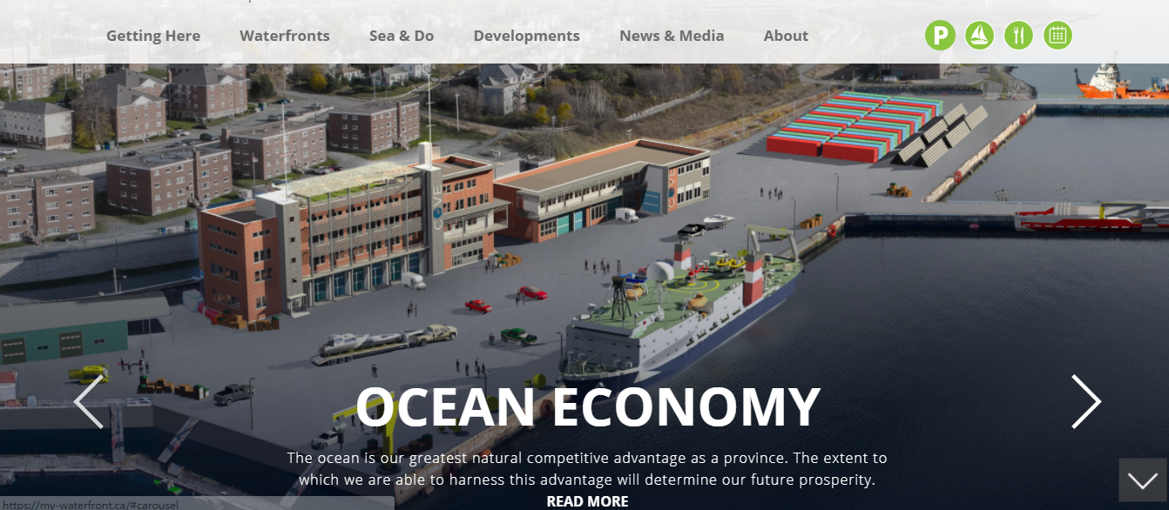

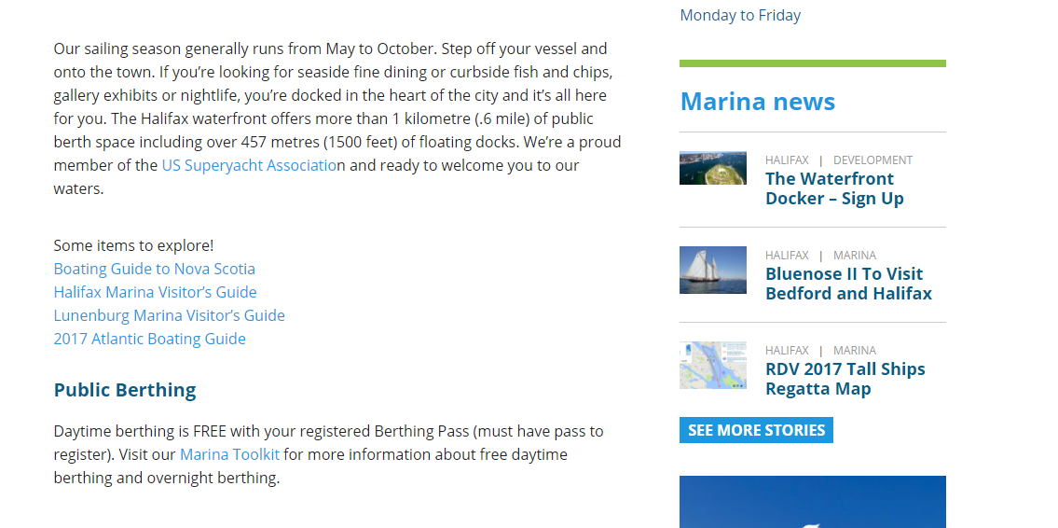

1. The next principles are “User control and freedom”. Every website must set a “emergency exit”, so it should support undo and redo. For example, if some people click “links of interest” and get into Dalhousie official website accidentally, they could not find any support to back to homepage. After testing, this website can`t support users undo and redo, so it fails in this aspect.

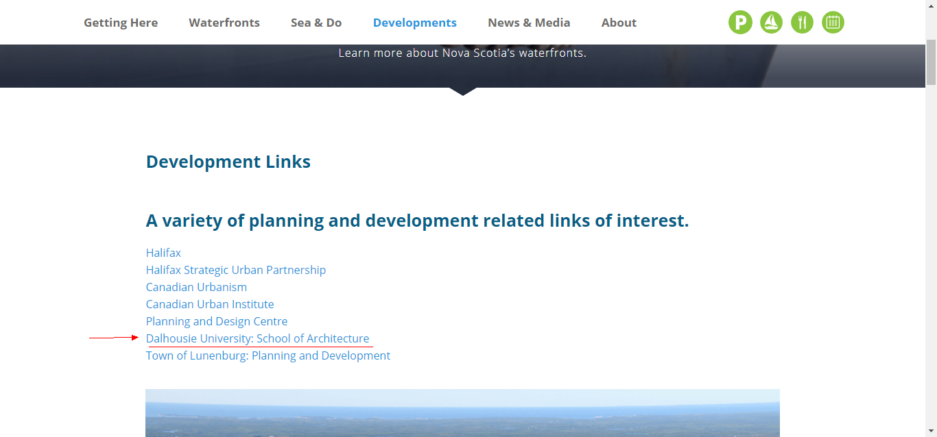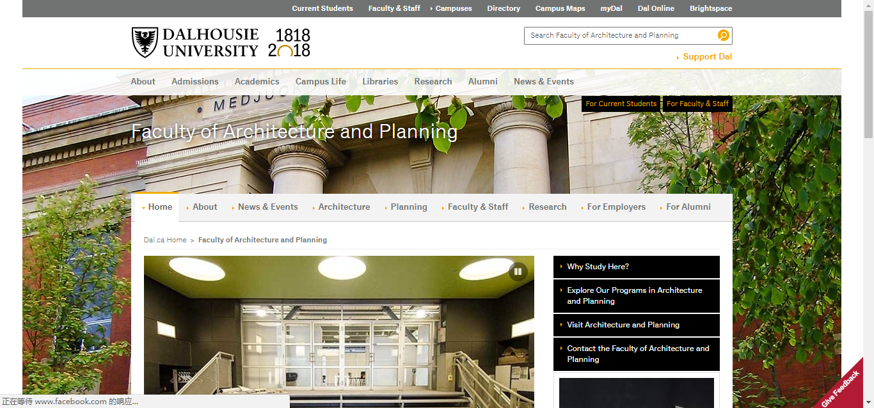

1. In the aspect of “Consistency and standards”, this website is doing well, it does not have any polysemy words or misleading sentence. All of marks, words and sentence are easy to understand without any argues and mistakes. This website meets these standards completely, so it passes in this aspect.

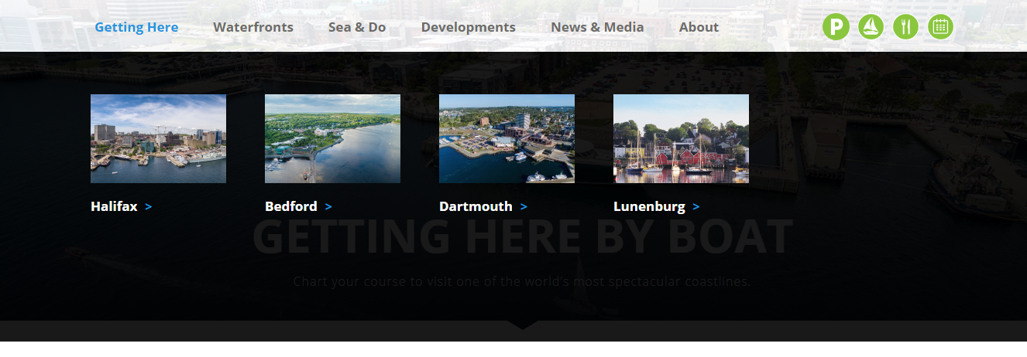

1. The next principle is “Error prevention”, after some quick tests. we find that there is no confirmation system in this website. When user input Special personal information such as, their cellphone number or email address, in the computer, they are not required to confirm and verify their personal information. Also, if some user wants to search “the development of the Halifax waterfront”, but he/she make a little mistake about then spelling when he/she type in, then he/she will fail for this searching, the website should support Intelligent searching service to solve this kind of problem. So, this website fails in this aspect.

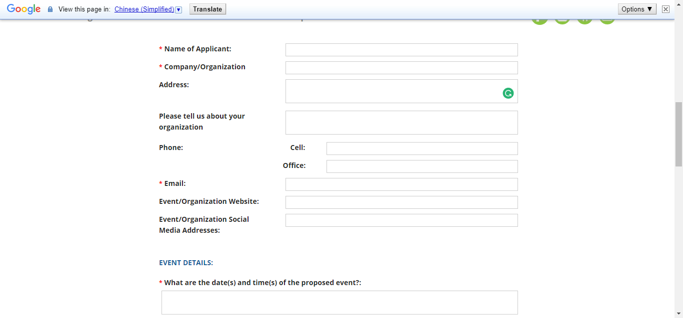

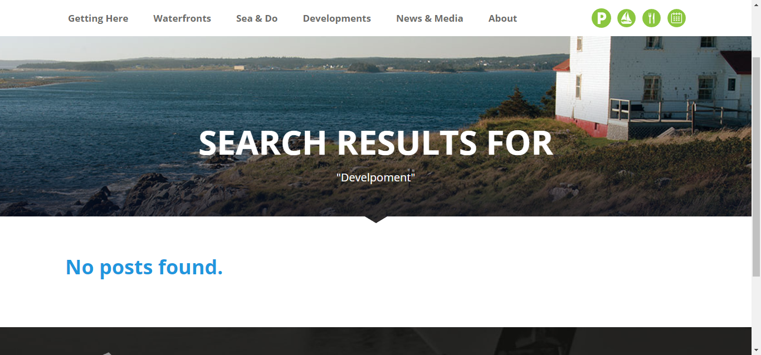

1. Another principle is “Recognition rather than recall”, which means the website system can recognizes the keywords that some users have been called before. It can “minimize the user's memory load by making objects, actions, and options visible” (Nilsen. J, 1995). Here is an instance, this website can save users` keywords in the memory of users` own computer. So, user don`t need to remember any keywords after they type these keywords in this website once. In addition, with this website system, people's searching efficiency has also been improved greatly. Generally, this website passes in this aspect.

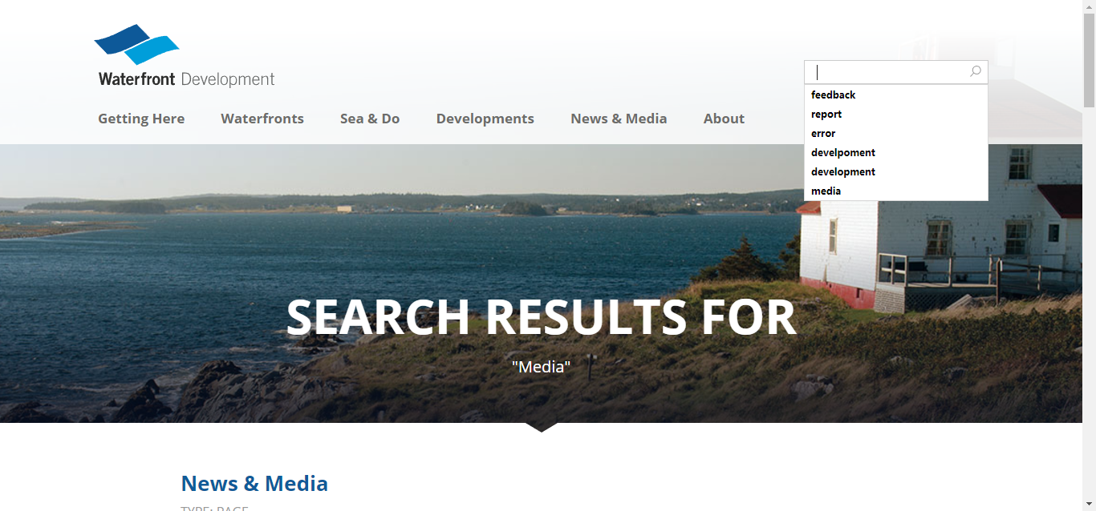

1. The next principle is “Flexibility and efficiency of use”. This is similar like recognition, the website can save users` privacy information in the memory of users` own computer, and it will full up this privacy information automatically when user login this website for the next time. Also, system should ask user to choose default installation or custom installation when user download some apps from this website, and the advanced user chooses a custom installation to cut out the unnecessary services. This website “Halifax Waterfront” succeeded in doing that. Because I`m not novice user for Twitter, so it perfectly full up my privacy information automatically when I go through the link to this website into Twitter, and I manually canceled the advertisement message of my Twitter. Admittedly, this function can not only speed up the interaction for the expert user but protect every user's privacy information. Certainly, this website passes in this aspect.

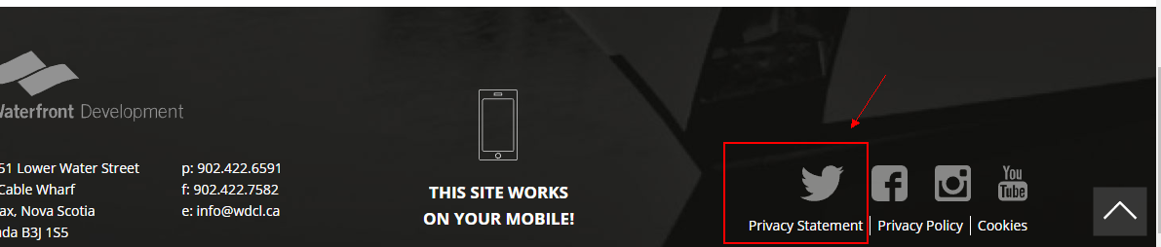

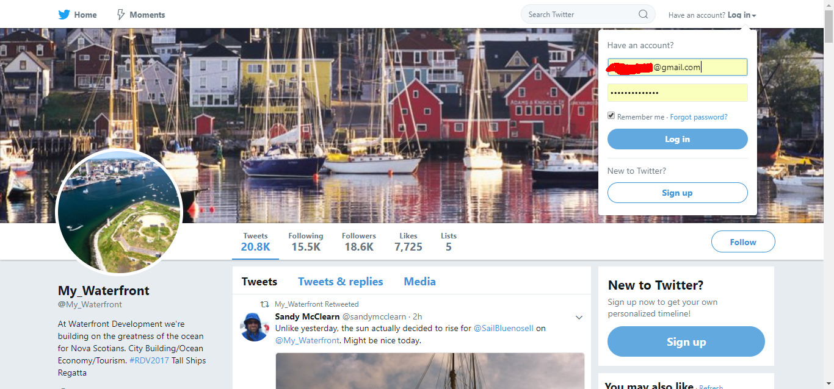

1. The eighth principle is “Aesthetic and minimalist design”. As we all know, a minimalist design always makes people feel freedom as well as comfortable. This website design caught up this point perfectly. All of contents use simple sentence, no matter they are introduction guides or social news. Every option of the menu is simplified to one or two words. User can clearly to understand what is the website talking about and easily to do their operation for every step. Moreover, the theme color of this website is blue because the website name is called “Halifax Waterfront”. So, this website passes the eighth principle successfully.

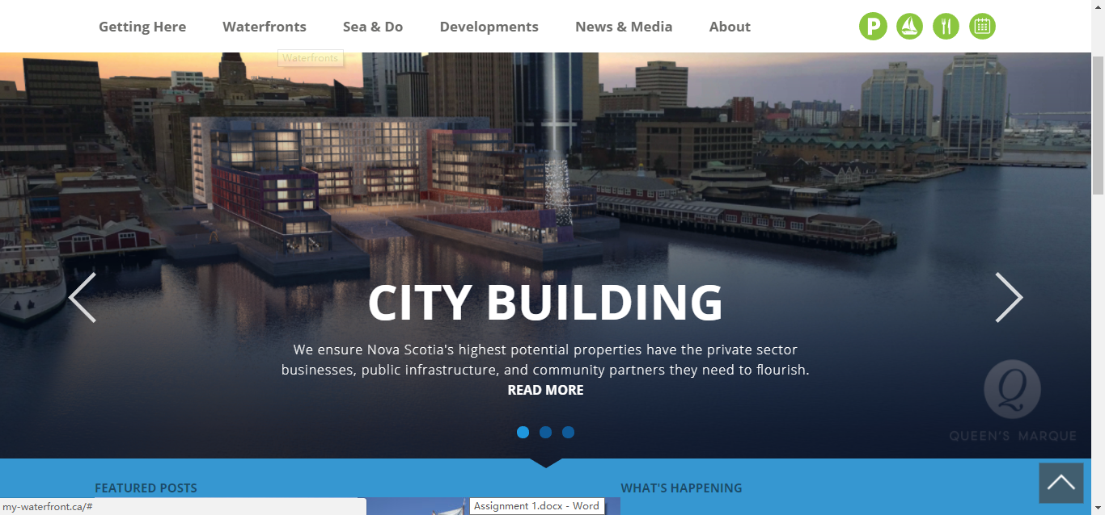

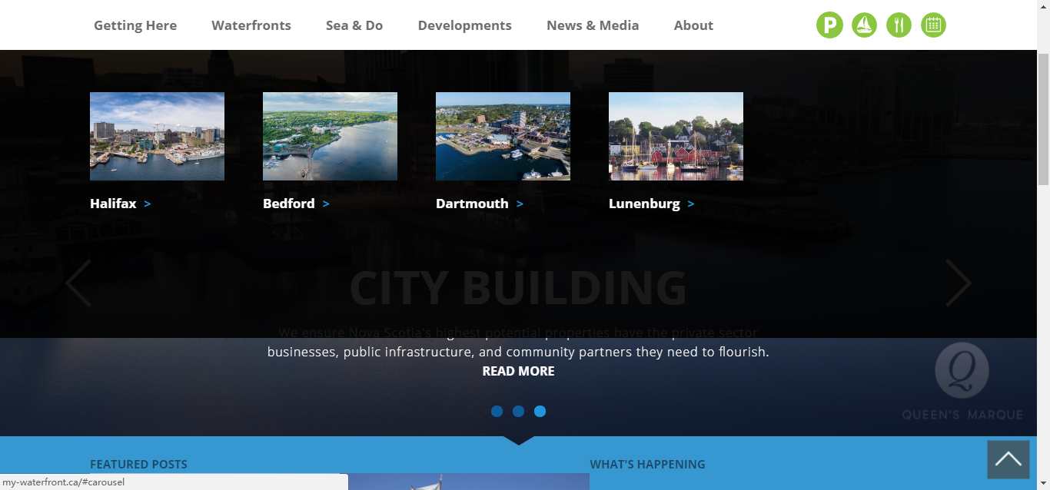

1. The next principle is “Help users recognize, diagnose, and recover from errors”. Not everybody is able to read and understand the computer language, not to mention the error massage, so the website designer should translate these complex codes to common language for user to read, and then help them to fix the problem or suggest a solution. However, the designers of website “Halifax Waterfront” just translate the error massage to some simple words but do not help user to solve the problem or even suggest some solutions. This website is not completely follow this principle. Therefore, it fails in this aspect.

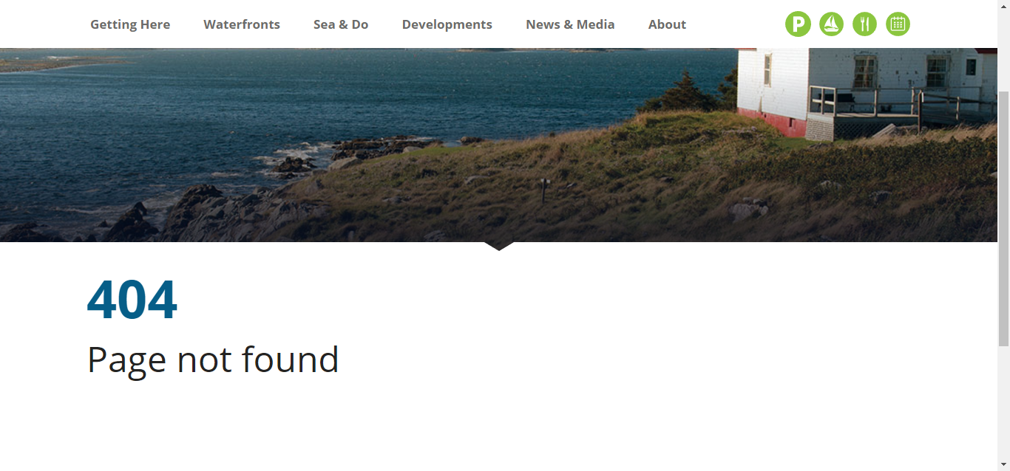

1. The last principle is “Help and documentation”. “A great user interface lets the user navigate through its features without any documentation or training. But if there is any user who could not make it out, adequate help should be provided within the product.” (Duggirala. S,2016). In this website, if some user need some help, then he/she can click the option which called “About” to see and find the help desk. So, this website passes the last principle successfully.

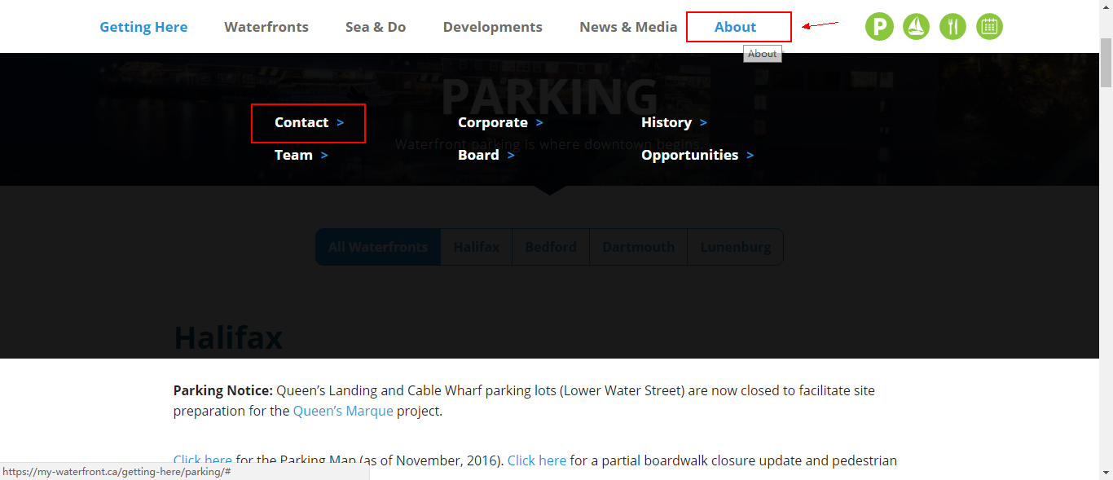

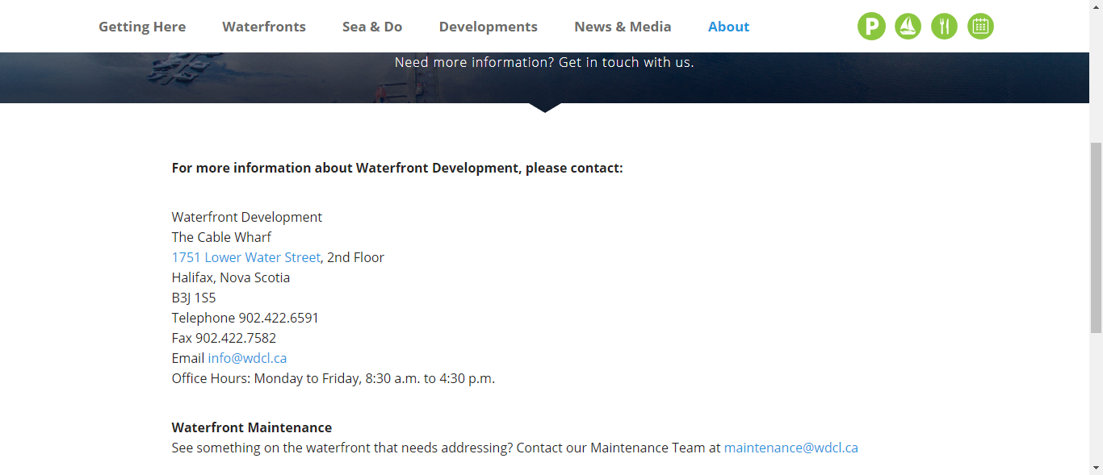

**A1.3**

**Website Wireframe Design and Justify.**

**A & B**  create a wireframe (base on the C.R.A.P design principles)

This is my website wireframe design drawing, in the next paragraph I will briefly describe my opinion of the design.

**Logo**

**Sign in help**

**Search**

**Links**

**&**

**News**

**Main Content**

**C** justify the design

My design is following four different concepts, which called CRAP principle, they are contrast, repetition, alignment, and proximity. So, let`s getting start to talk about the first concept, contrast. If the element is not the same, let them distinct. To avoid some similar elements on the page, I used different font, color, size and shape to divide each element. For example, the font size of title should be large enough because it need to catch users` eyes. Compare with title, the news and advertisement should be much smaller because user don’t need to read every single word carefully. In general, the fundamental purpose of contrast is not only enhanced page effect but also help to organize information.

The second concept is repetition. To make the visual elements of the design is repeated throughout the work, I keep every word which in same parts to be same font, size and color, and all of wireframes shape are rectangle or square. This kind of layout can unify and enhance the visual effect, and it also easier for user to read and even look through. For example, if my website theme is about saving water, and the color of my website logo is blue, then the color of my paragraphs of text and title should be blue as well. It can increase the clarity and will not make user feels unexpected. Consider about that, repetition for multi-page document design is more important.

The next concept is alignment. Just like the golden ratio, people always pursue the aesthetic feeling involuntarily, nothing can easily be placed on a page. I`m not going to make the layout of my website become very delicate, but at least it should be generous and decent. In addition, I don’t want to make my website looks too traditional, like a newspaper, so I tried to not make all of text information centered. For the row and column, all the wireframes have aligned each other, this is what the concept requires and it is also what I want.

The last concept is proximity. To make the information placed with better structure, I grouped the related information points together. I had concerned that put some short and brief information, such as weather, date, Register or login windows, all together in the blank corner before I read the CRAP principle, but now I abandon that idea. Just imagine that, if a user is interested in the website that design by me. However, he/she can easily find the login windows, but cannot find where the registration window is, and finally, he/she find it at a small corner and near by the electronic calendar. This would be resulting in poor user experience, and I would lose one customer because of that. So, I grouped the related information to the same part, and these information is eventually divided into four different parts, logo, main content, link & news and service area. That is all justify for my design, most of design concepts are following the CRAP principle. Admittedly, I learned lots of useful skills with the CRAP principle.

**D** identify.

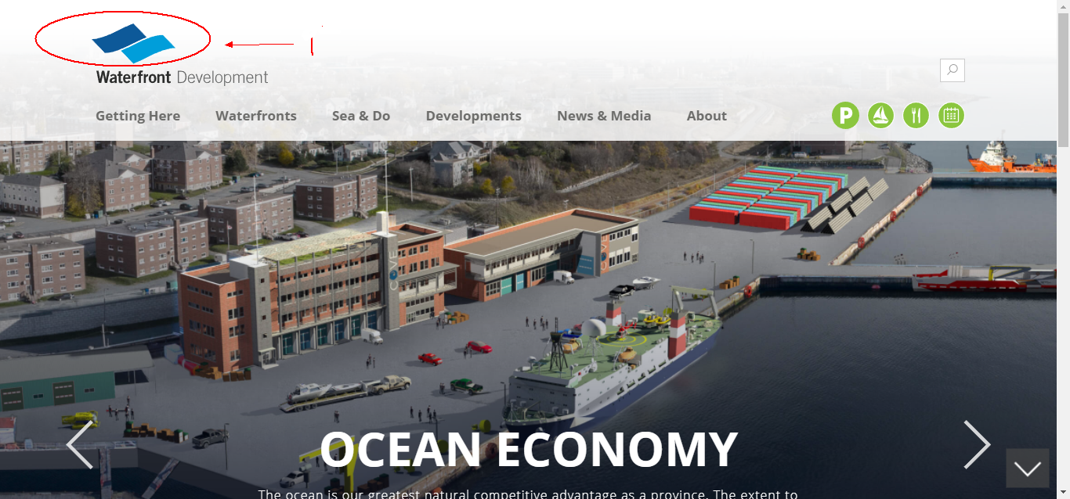

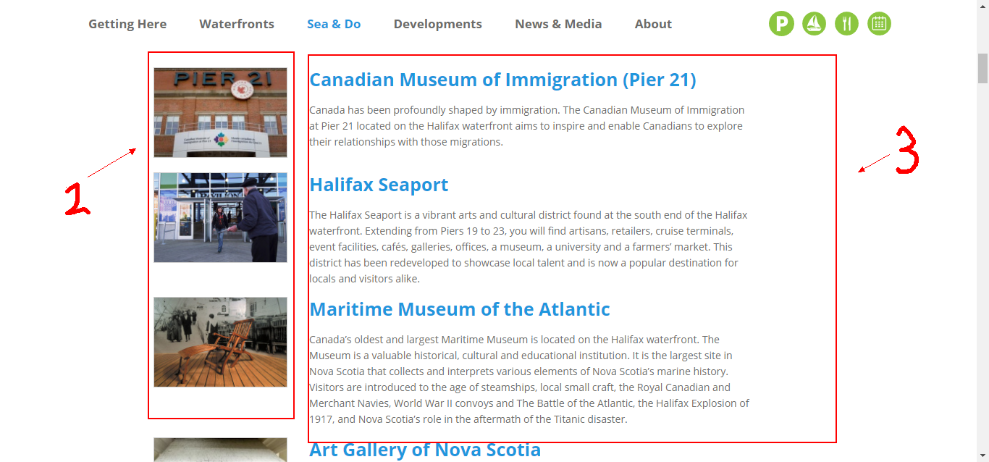

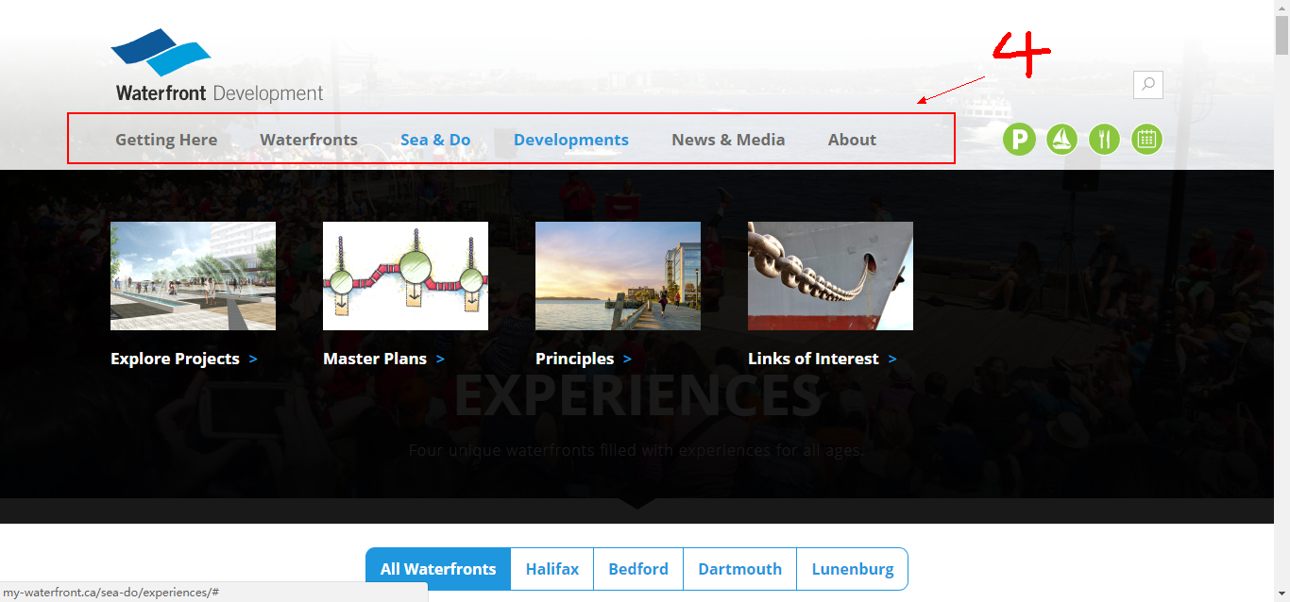

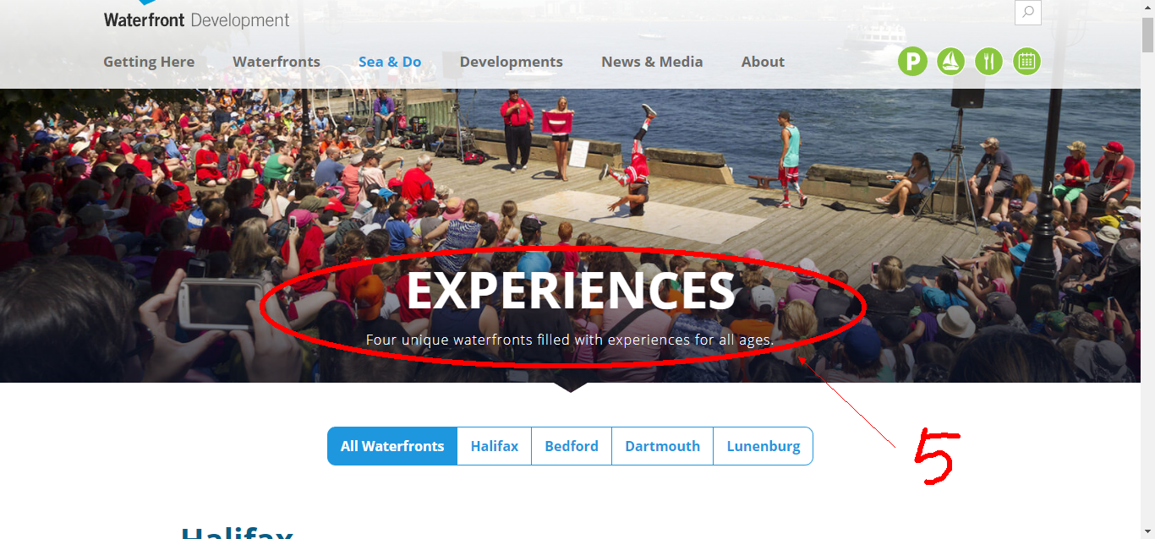

1. Mark No.1 is logo
2. Mark No.2 are images
3. Mark No.3 are paragraphs of texts
4. Mark No.4 are options
5. Mark No.5 is title